Levels 3-10
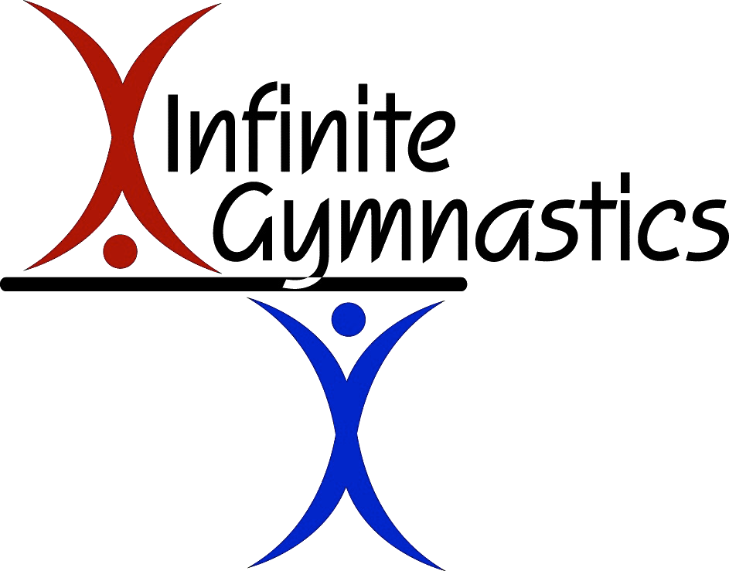

Infinite Gymnastics Boys’ Team

2022-2023 Competition Packet

Inside This Packet:
- Answers to Frequently Asked Questions About Competitions
- Meet Etiquette for Athletes and Families
- Explanation of Fees Associated with Competitions
- 2022-2023 Competition Schedule

Participation in Meets:
Answers to Frequently Asked Questions about Competitions

How many meets should my child enter?

Ideally, we would like the boys to enter every competition. However, we understand that not all families will be able to make that commitment. Therefore, we request that the boys enter at least 4 of the meets, with one of them being the season finale – Wisconsin State Championships.

How do I know what day the meet is on?

Please note that all meets on the calendar usually have both a Saturday and Sunday date listed (in some cases Friday, too). Team entry fees (paid with a club check) are usually due 6-8 weeks prior to the competition date. This deadline varies based on the meet host and, due to the popularity of some of the meets, they sometimes “fill up,” 3 or 4 months in advance. Once the meet director receives all team entries, they begin creating the meet schedule. We are completely at the mercy of the meet host, and they can assign any level to any day or time slot. We will be notified what day Infinite will be competing 7-10 days before the meet. Once this info is received, it will be posted on the TeamApp. Each gymnast will only be required to attend for one session (about 3-4 hours long.)

What if we cannot attend?

To register for meets, you must return the form at the end of this handbook. If you decide to no longer attend a previously registered for competition, you MUST email the gym at infinite1gym@gmail.com.

We cannot guarantee a refund for meets dropped less than one month before the Meet Date. Refunds are dependent upon the host meet director’s discretion.

-No refunds will be issued for last-minute withdrawals

What is the competitive dress code?
- COMPETITION LEOTARD: Gymnasts are required to wear a competition leotard. Competition leotards can be worn for years, as long as the child does not outgrow them. We typically change our leotard style every 2-3 years.
- SOLID BLACK LEGGINGS: Black leggings are worn over competition leotards to warm-up in. Only the black leggings sold on the Infinite Uniform Order will be allowed.
- SOLID BLACK SHORTS: Black shorts are optional to wear over the competition leotard while competing. If choosing to wear shorts, only the black shorts sold on the Infinite Uniform Order will be allowed.
- TEAM JACKETS: Infinite Team Jackets are a requirement. They will have the Infinite name and logo with the option to add your gymnast’s name on the chest.
- HAIR: Hair should be secured away from the face and neck Clips, bobby pins, and hair spray may be used to keep strands of hair from falling down. Hair that falls into a gymnast’s face is a safety risk and results in a score deduction.
- ACCESSORIES: There is a deduction for any kind of jewelry, as well as any nail polish worn on the fingers or toes. Small studs can be worn in the ears for competition, but that is it.
- Please make sure your gymnast looks their very best when representing Infinite!

How do we come prepared?

- Gymnasts should come wearing their complete team uniform (competition leotard, team jacket, solid black leggings, and gym bag)
- Any personal equipment needed should be in gym bag (EX: if they have grips, tiger paw, or braces.)
- Other things to include in the gym bag:
  - Water bottle
  - Tape or pre-wrap (if needed)
  - Deodorant or other personal items
  - Very light NON-MESSY snack
  - Extra hair ties, clips, hairspray
**Please write your child’s name on everything!

If your gymnast will be carrying a bag on the competition floor, it must be an Infinite bag. Otherwise, parents must be prepared to hold all items!

Meet Etiquette for Athletes and Families
Whether your meet is in your own facility or in another team’s gym, it is important that you and your athlete remember that hosting a meet takes a great deal of work. The hosting gym receives a roster of athletes from each gym wishing to participate in the competition. To give everyone an equal opportunity to take part in the meet, a deadline date is usually established. The deadline for entries can be from one week to months prior to the event. When the hosting gym gets all of the rosters, they may then begin to establish sessions and times. This all takes time. Please DO NOT call the hosting gym for information. The proper etiquette is to ask your own coaches.
It is his/her responsibility to furnish you with this information. Sometimes there are unforeseen problems that might cause a delay in this information being communicated, so be please patient.

Etiquette for Families:
Each gym club has a set of rules and regulations that have been established for your comfort and safety. ALWAYS follow the hosting gym’s rules. Here are a few rules that are common to ALL meets:
- No Flash Photography
- No Parents or Siblings on the Competition Floor/Area (there will be designated spectator seating)
- No Food or Drinks in the Gym
- No Parents Allowed to Question a Judge
- No Spectators Allowed on Any Equipment
- No Profanity
- No Unsportsmanlike Behavior
- No Destruction of Gym Property

Door Fees for Spectators:

Some host clubs charge a fee for spectators at competitions. These fees range from $10-20 per person. These fees help the host gym cover the expense of running the event.

Arrival:

Gymnasts should arrive at the arrival time listed on the schedule to check in with their coach. This is typically 10-15 minutes before the competition starts. Timeliness allows gymnasts to start their team warm-up on time, creating a less stressful experience, and is the key to them mentally preparing for a good performance in the competition arena.

General Meet Etiquette:

- Once the gymnasts are at the meet with their coach, the coach is in charge of them at that time – The parents’ role is to SUPPORT FROM THE STANDS! (Be their best cheerleader!)
*Please Note: A gymnast will receive a deduction if their parent is overheard coaching them from the sidelines.
- Gymnasts should remain in the competitive area until after the awards ceremony unless instructed to do otherwise by their coach.

Good Sportsmanship:

It is important to remember that a score for any routine is just an evaluation of a single performance. Regardless of the outcome of a routine or competition, good sportsman-like conduct is expected of all Infinite gymnasts, and individual attitudes can affect the entire team. Crying, poor attitude, and feeling sorry for oneself is not an appropriate response. Always remember that we never lose – we either win or we learn!

*Cheering for your teammates (and others) is REQUIRED!!!
**Badmouthing ANYONE is not allowed!

A Note About Nerves:

It is difficult to predict how an athlete will respond to the nerves that come along with competing. For some, it gives them a boost of adrenaline and they actually perform better than they do in practice. For others, the nerves are literally debilitating, and a gymnast can shut down and forget everything they have been working on in practice! We try our best to prepare them for competition both physically and mentally, but anything can happen at a meet! It is important that we (coaches and parents) teach our athletes how to respond and deal with stressful situations because it will not only help them become better performers and competitors, it will help them deal with the uncertainties and stressful situations that will arise throughout their life!

Etiquette Continued…
Explanation of Fees:

Infinite Gymnastics’ Annual Team Registration Fee:
Every year on June 1st, an annual Team Registration Fee of $115.00 is due and payable to INFINITE GYMNASTICS. This fee covers the following team specific items that are not covered in tuition, these are:
- Gym registration
- Tape & Chalk usage
- Administrative costs
- Insurance

Competition Uniform:
Gymnasts are required to purchase the competition uniform outlined on page 1 of this handbook.

Coaches Fees:
Coaches fees are based on the coaching costs associated with each competition. These fees cover the coaches’ expenses such as travel, food, and lodging. These fees are divided evenly among all athletes who attend the competition. Fees will vary by competition.

USA Gymnastics Membership Fees:
Parents MUST complete all USAG registration online so that the gymnast can receive her athlete number and registration for the season. It is also used as an insurance and comes with several other USAG benefits. Please see the attached How-to Guide for directions to register. This membership must be renewed each year. USAG sets the fees for membership. We cannot register your gymnast for meets until you purchase their USAG membership.

Entry Fees:
Entry fees for competitions vary per event based on the level of competition, the location and the nature of the competition (Invitational, State Championship, Regionals, etc.) (Entry fees are set by meet hosts, not by Infinite). *Team Fees will be included in entry fees.*

Receiving Awards in Public:

Most meets have a formal system for presenting awards. As an athlete, a demonstration of courtesy and gratitude is appropriate. In addition:

- You should accept awards in your TEAM UNIFORM only.

- No gum or candy.

- Congratulate the other athletes receiving awards as well.

- Stay on the awards podium for a brief time after all gymnasts have received their award –Family members will want to take pictures of you on the platform!

- Under no circumstances should you show disappointment for an award that you are given.

- Not everyone wins an award every time. That is the crazy thing about life. However, we must understand that the only way that we truly LOSE is if we do not LEARN from the mistakes that we make. *This is where we go back to the gym to practice and continue to work hard at fixing those mistakes! ☺

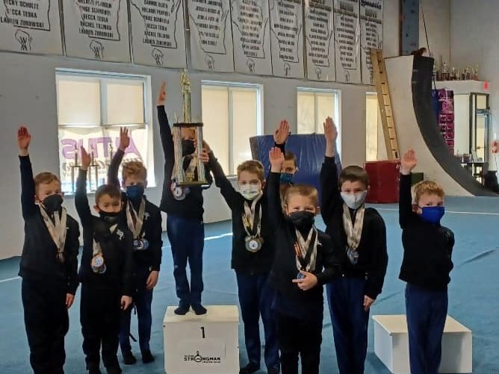

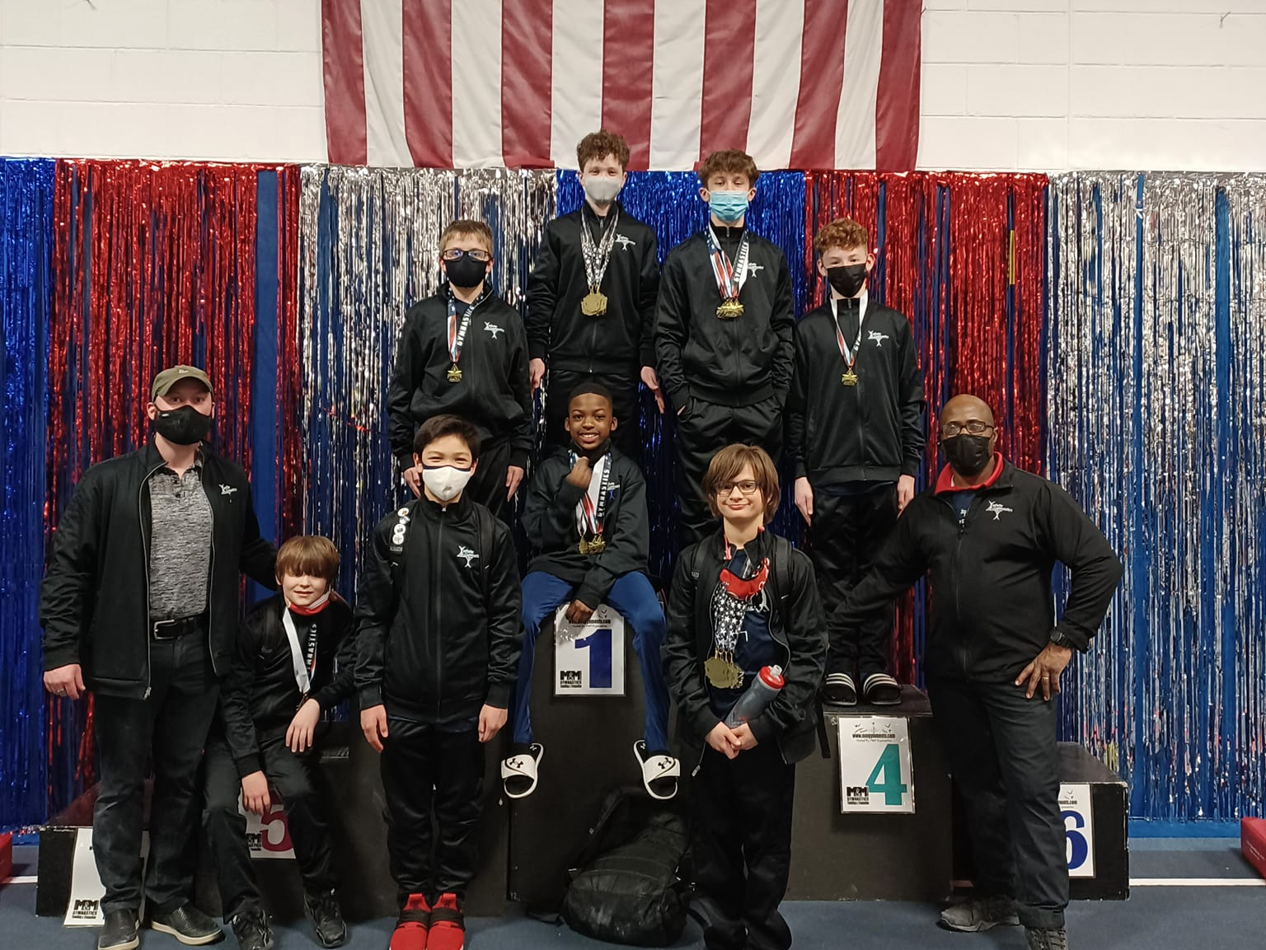

OTHER THINGS TO NOTE:

- UNIFORMS:
  - Uniforms are for COMPETITION ONLY and should never be worn for practice!! To keep them looking fresh, turn them inside out to wash and dry. Low heat/cold water is best!

- EVENT ROTATION ORDER:
  - Gymnasts always rotate in “Olympic Order” which is - Floor Exercise, Pommel Horse, Still Rings, Vault, Parallel Bars, High Bar (If we start on Pommel Horse, for example, then we will rotate- Pommel Horse, Still Rings, Vault, Parallel Bars, High Bar, Floor Exercise Floor, Vault. If we start on Vault, we will rotate Vault, Parallel Bars, High Bar, High Bar, Floor Exercise, Pommel Horse, Still Rings. Every meet rotates in this order (which is helpful to know when wondering what event we will go to next)!
  - Sometimes we will get to choose our order for who competes first, second, third, etc. Sometimes the orders will be generated randomly before arrival. Every meet is an exciting new experience!

- VISUALIZATION:
  - Mentally prepare for your competition THE NIGHT BEFORE! See yourself doing your routines PERFECTLY in your head!!
  - Visualization is a great tool for success - not just in gymnastics, but in every aspect of your life!
  - When you are visualizing, imagine you are in a large stadium with a large audience and judges and cameras and the whole shebang!
  - Put yourself in the stressful situation mentally and imagine how you will succeed there! How do you have to stick your handstand on beam? What do you need to remember to do on bars? How will you stick your tumbling and vault, etc.?

- REMEMBER – WE ARE DOING THIS FOR FUN:
  - Sometimes you will have a good meet. Sometimes you will have a bad meet. Remember that nothing that happens at this level of competition really matters in the grand scheme of life. People make mistakes at competitions and it is not the end of the world! What matters is how you respond after you make those mistakes! Always show grace in defeat. After each competition, we will go to the gym and work hard on trying to fix our mistakes. It is an important life lesson to learn that failing is a part of growing, and that no competition or single performance – good or bad – defines you as a person.

2022-2023 Competition Schedule
PARENT COPY
Recommended that you circle the meets that you are asking to be registered for.
Date | Competition | Location | Levels Attending | Entry Fees /  Due Date | Coaches’ Fees /  Due Date
Dec. 16 | Jump Around Gymnastics Judges Meet | Jump Around Gymnastics  7129 River Rd. Deforest, WI 53532 | 3, 4, 5 | $115  Oct. 15 | TBD  January 1
Jan. 8 | Strong Man Invite Altius Gymnastics | Altius Gymnastics  9670 S. Franklin, WI 53132 | 3, 4, 5 | $115  Nov. 1 | TBD  February 1
Jan. 13-16 | Windy City Invite | TBD | 7, 8, 9, 10 | $165  Sept. 1 | TBD  February 1
Jan. 22-23 | Twin City Invite | Mini Hops Gymnastics | 7, 8, 9, 10 | $165  Sept. 15 | TBD  February 1
Jan. 28-29 | M&M Invite M&M Gymnastics | M&M Gymnastics  16760 W. Victor Rd. New Berlin, WI 53151 | 3, 4, 5 | $115  Nov. 15 | TBD  February 1
Feb. 4-5 | Infinite Gymnastics Cup Challenge | Infinite Gymnastics  8989 N. 55th St. Brown Deer, WI 53223 | 3-10 | $115  Dec. 15 | TBD  March 1
Feb. 11-12 | Scamps Invite Scamps Gymnastics | Scamps’ Gymnastics  5711 77th St.  Kenosha, WI 53142 | 3, 4, 5 | $115  Jan. 1 | TBD  March 1
Feb. 18-19 | Harley Davis | Midwest Express Center Milwaukee, WI | 3-10 | $165  Oct. 1 | TBD  March 1
March 4-6 | Salto Invite Salto Gymnastics | State Fair Park | 3-10 | $165  Dec. 1 | TBD  April 1
March 25 | State Championship Airfare | Green Bay, WI | 3-10 | $165  Jan. 15 | TBD  April 1

PLEASE NOTE:

- Gymnasts will be entered into the competitions that you select on the next page.
- The Meet Entry Fees have been estimated on the high side, as we are still waiting for some meets to provide Entry Fee information. Any residual Meet Entry Fees that have been paid will be credited back to your account to be used towards tuition, meet fees, and coaches fees.
- If you wish to WITHDRAW from a previously registered competition, you MUST email the gym at infinite1gym@gmail.com.
April 1 | Regional Championships | TBA | 4-10 | $165  Feb. 15 | TBD  May 1
April 28-30 | Western Nationals | TBA | 7, 8, 9 | $165  Feb. 15 | TBD  May 1
May 9-14 | J.O. Nationals | TBA | 9-10 | $165  Jan. 15 | TBD  June 1

  - We cannot guarantee a refund for meets dropped less than one month before the Meet Date. Refunds are dependent upon the host meet director's discretion.

CHECK YES OR NO & RETURN
Please return by THURSDAY, SEPTEMBER 1st
______________________________________ ___________________
Gymnast’s Name Level
Jan. 28-29 | M&M Invite M&M Gymnastics | M&M Gymnastics  16760 W. Victor Rd. New Berlin, WI 53151 | 3, 4, 5 | $115  Nov. 15 | TBD  February 1
Feb. 4-5 | Infinite Gymnastics Cup Challenge | Infinite Gymnastics  8989 N. 55th St. Brown Deer, WI 53223 | 3-10 | $115  Dec.15 | TBD  March 1 | YES

Date | Competition | Location | Levels Attending | Entry Fees /  Due Date | Coaches’ Fees /  Due Date | YES OR NO
Dec. 16 | Jump Around Gymnastics Judges Meet | Jump Around Gymnastics  7129 River Rd. Deforest, WI 53532 | 3, 4, 5 | $115  Oct. 15 | TBD  January 1
Jan. 8 | Strong Man Invite Altius Gymnastics | Altius Gymnastics  9670 S. Franklin, WI 53132 | 3, 4, 5 | $115  Nov. 1 | TBD  February 1
Jan. 13-16 | Windy City Invite | TBD | 7, 8, 9, 10 | $165  Sept. 1 | TBD  February 1
Jan. 22-23 | Twin City Invite | Mini Hops Gymnastics | 7, 8, 9, 10 | $165  Sept. 15 | TBD  February 1

Feb. 11-12 | Scamps Invite Scamps Gymnastics | Scamps’ Gymnastics  5711 77th St.  Kenosha, WI 53142 | 3, 4, 5 | $115  Jan. 1 | TBD  March 1
Feb. 18-19 | Harley Davis | Midwest Express Center Milwaukee, WI | 3-10 | $165  Oct. 1 | TBD  March 1
March 4-6 | Salto Invite Salto Gymnastics | State Fair Park | 3-10 | $165  Dec. 1 | TBD  April 1
March 25 | State Championship Airfare | Green Bay, WI | 3-10 | $165  Jan. 15 | TBD  April 1 | YES
April 1 | Regional Championships | TBA | 4-10 | $165  Feb. 1 | TBD  May 1
April 28-30 | Western Nationals | TBA | 7, 8, 9 | $165  Feb. 15 | TBD  May 1
May 9-14 | J.O. Nationals | TBA | 9-10 | $165  March 1 | TBD  June 1

We request that the boys enter at least 4 of the meets, with one of them being the Infinite Gymnastics Cup Challenge, and State Championships.

All meet fees will be automatically charged to your payment method on file unless we receive other payment prior to the due date.

______________________________________ ______/______/______
Parent’s Signature Date

Team Parent Pre-Season Checklist

- Read 2022 Competition Packet
- Complete USA Gymnastics Registration (done online) - Due September 1st
- Turn in Competition Registration Form - Due September 1st
- Turn in Uniform Order - Due September 1st
- Email Coach Mitch at mitchellconnor65@gmail.com with any questions!

